📘 Git Beginner’s Guide
🔑 What is Git?
Git is a distributed version control system (DVCS) created by Linus Torvalds in 2005 that helps developers track changes in code, collaborate across teams, and revert to previous versions when needed. A simple example is creating a repository, adding a file, and committing changes to maintain a history of updates.
🔑 Definition of Git
- Git is a distributed version control system (DVCS).
- It allows multiple developers to work on the same project simultaneously, even offline.
- Every developer has a full copy of the project history on their local machine.
- Git is widely used with platforms like GitHub, GitLab, and Bitbucket for collaboration.
⚙️ Key Concepts
- Repository (Repo): Central hub where project files and history are stored.
  - Local Repository: This is a copy of the repository which is stored in your computer. You can work on your project and make changes here.
  - Remote Repository: This is stored on a server, like GitHub, where you and others can share and work on a project.
- Commit: A snapshot of changes saved in the repo.
- Branch: A separate line of development (e.g., main, feature-x).
- Merge: Combining changes from one branch into another.
- Clone: Copying a remote repository to your local machine.
- Staging Area: Where files are prepared before committing.

📘 Quick Analogy
Think of Git like a camera:
- Untracked → A new object not yet in the photo album.
- Staged → You’ve lined up the object in the frame, ready to take a photo.
- Commit → You press the shutter, and the photo is saved in the album.
- Modified → You change the object after the photo was taken.

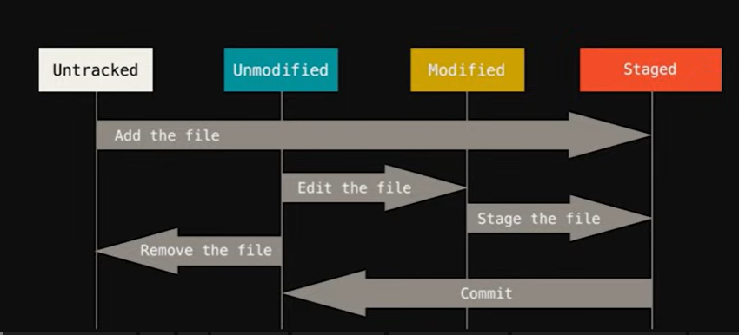
🔹 Git File States
- Untracked
  - A file that exists in your working directory but Git is not tracking it yet.
  - Example: You create a new file notes.txt. Until you run git add notes.txt, Git doesn’t know about it.
Transition:
  - Add the file → moves the file from Untracked → Staged.
- Staged
  - A file that has been marked to be included in the next commit.
  - Think of it as “ready to be photographed.”
  - Example: After git add notes.txt, the file is staged.
Transition:
  - Commit → moves the file from Staged → Unmodified (because the snapshot is now saved).
- Unmodified
  - A file that is already committed and hasn’t been changed since.
  - Example: After committing, notes.txt is unmodified because it matches the last snapshot in Git.
Transition:
  - Edit the file → moves the file from Unmodified → Modified.
  - Remove the file → moves the file from Unmodified → Untracked (Git stops tracking it).
- Modified
  - A file that has been changed but not yet staged.
  - Example: You edit notes.txt after committing. Git sees it as modified.
Transition:
  - Stage the file → moves the file from Modified → Staged (ready for commit again).

🚀 Essential Git Commands (with Explanations)
Setup & Initialization
- git init → Creates a hidden .git folder in your project. Git starts tracking changes here.
- git clone <url> → Copies a remote repository (e.g., from GitHub) to your local machine.
- git config --global user.name "Your Name" → Sets your identity for commits.
- git config --global user.email "your_email@example.com" → Sets your email for commits.

Status & History
- git status → Shows which files are untracked, modified, or staged.
- git log → Displays commit history with author, date, and message.
- git show <commit-id> → Shows details of a specific commit.

Staging & Committing
- git add <file> → Stages only the specified file. Use when committing selectively.
- git add . → Stages all modified and new files in the current directory. Faster, but may include unwanted files.
- git commit -m "Message" → Saves a snapshot of staged changes with a descriptive message.
- git diff → Shows differences between working directory and staging area.
- git diff --cached → Shows differences between staging area and last commit.

Branching & Merging
- git branch → Lists all branches.
- git branch <name> → Creates a new branch.
- git checkout <name> → Switches to another branch.
- git checkout -b <name> → Creates and switches to a new branch in one step.
- git merge <branch> → Merges changes from another branch into the current one.

Remote & Collaboration
- git remote add origin <url> → Links your local repo to a remote (e.g., GitHub).
- git remote -v → Shows remote connections.
- git push origin main → Uploads commits to GitHub.
- git pull origin main → Fetches and merges changes from GitHub.
- git fetch → Downloads changes without merging.

Ignore Files
- Create a .gitignore file:
- *.log
- __pycache__/
- .env
→ Prevents unnecessary files (logs, cache, secrets) from being tracked.

Undo & Recovery
- git reset HEAD <file> → Unstages a file but keeps changes.
- git checkout -- <file> → Discards changes in a file.
- git revert <commit-id> → Creates a new commit that undoes a previous one (safe for shared repos).
- git stash → Temporarily saves work.
- git stash pop → Restores stashed work.

🌐 Connect to GitHub with SSH
- Generate SSH Key → ssh-keygen -t rsa -b 4096 -C "your_email@example.com"
- Start Agent → eval "$(ssh-agent -s)"
- Add Key → ssh-add ~/.ssh/id_rsa
- Copy Public Key → cat ~/.ssh/id_rsa.pub
- Add Key to GitHub → Settings → SSH Keys.
- Test Connection → ssh -T git@github.com
- Push via SSH →
- git remote add origin git@github.com:username/repo.git
- git push -u origin main

⚠️ Troubleshooting & Conflict Resolution
Merge Conflicts
- Git marks conflicts with <<<<<<<, =======, >>>>>>>.
- Edit the file manually, keep the correct version.
- Stage and commit the resolved file.
Common Issues
- Accidentally staged wrong file → git reset HEAD <file>
- Discard local changes → git checkout -- <file>
- Undo last commit but keep changes → git reset --soft HEAD~1
- Undo last commit and discard changes → git reset --hard HEAD~1
- Push rejected (remote has new commits) → git pull --rebase origin main
- Detached HEAD state → git checkout main

📊 Advantages of Git
- Distributed system → Every developer has a full copy of history.
- Fast branching & merging → Lightweight workflows.
- Offline work → No central server required.
- Collaboration → Easy integration with GitHub, GitLab, Bitbucket.
- Data integrity → Commits are checksummed.

🔄 Git vs Other Tools
Feature | Git (DVCS) | SVN (Centralized) | Mercurial (DVCS)
Offline Work | ✅ Yes | ❌ No | ✅ Yes
Full History Copy | ✅ Yes | ❌ No | ✅ Yes
Branching | Fast & easy | Heavy & slower | Fast
Popularity | Very high | Declining | Moderate
Collaboration | GitHub/GitLab | Requires central server | Bitbucket support

✅ Best Practices
- Make small, frequent commits with clear messages.
- Use branches for features/bugs.
- Always pull before pushing.
- Use .gitignore to keep repos clean.
- Review changes with git diff before committing.

